Exercise 1:

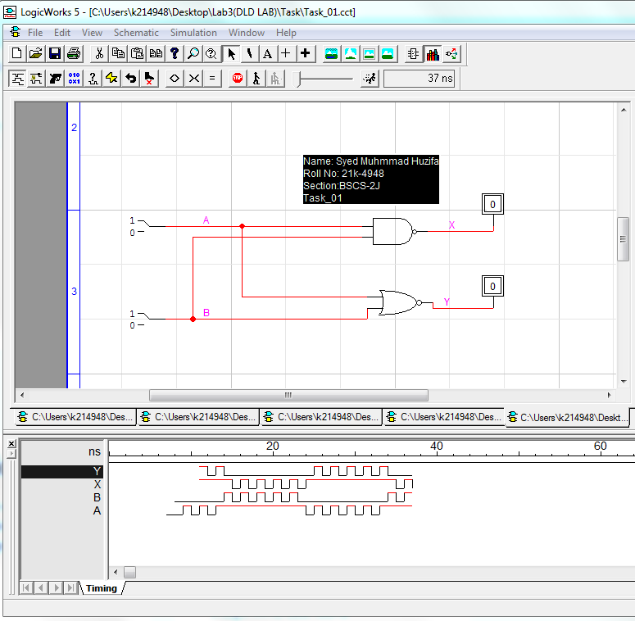

|  |  |  |  |
| --- | --- | --- | --- |
| A | B | X | Y |
| 0 | 0 | 1 | 1 |
| 0 | 1 | 1 | 0 |
| 1 | 0 | 1 | 0 |
| 1 | 1 | 0 | 0 |

Exercise 2:

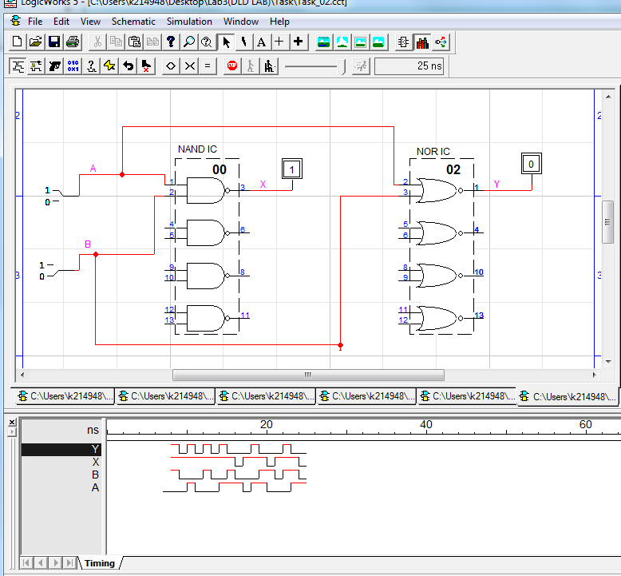

|  |  |  |  |
| --- | --- | --- | --- |
| A | B | X | Y |
| 0 | 0 | 1 | 1 |
| 0 | 1 | 1 | 0 |
| 1 | 0 | 1 | 0 |
| 1 | 1 | 0 | 0 |

Exercise 3:

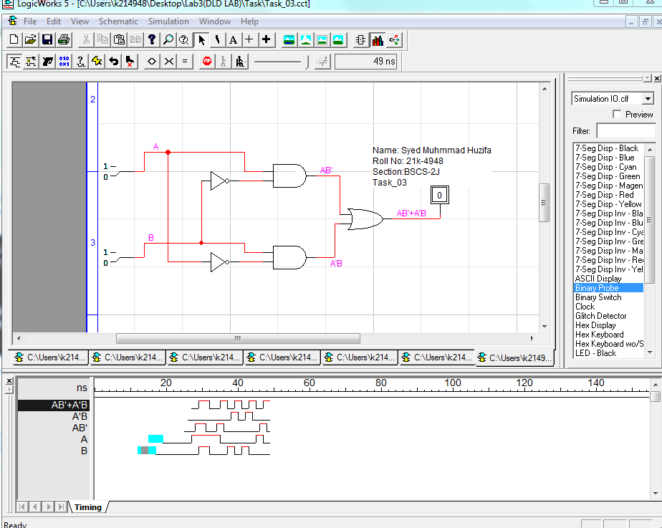

|  |  |  |
| --- | --- | --- |
| A | B | X |
| 0 | 0 | 0 |
| 0 | 1 | 1 |
| 1 | 0 | 1 |
| 1 | 1 | 0 |

Exercise 4:

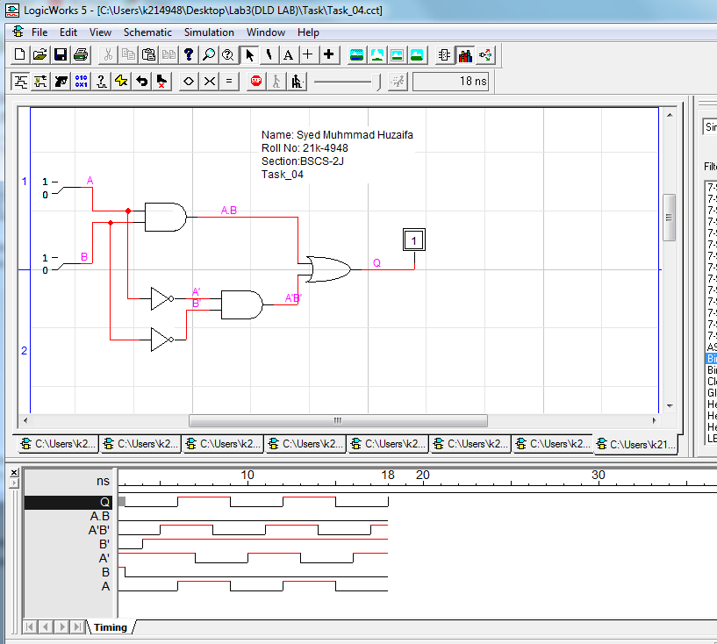

|  |  |  |
| --- | --- | --- |
| A | B | X |
| 0 | 0 | 1 |
| 0 | 1 | 0 |
| 1 | 0 | 0 |
| 1 | 1 | 1 |

Exercise 5:

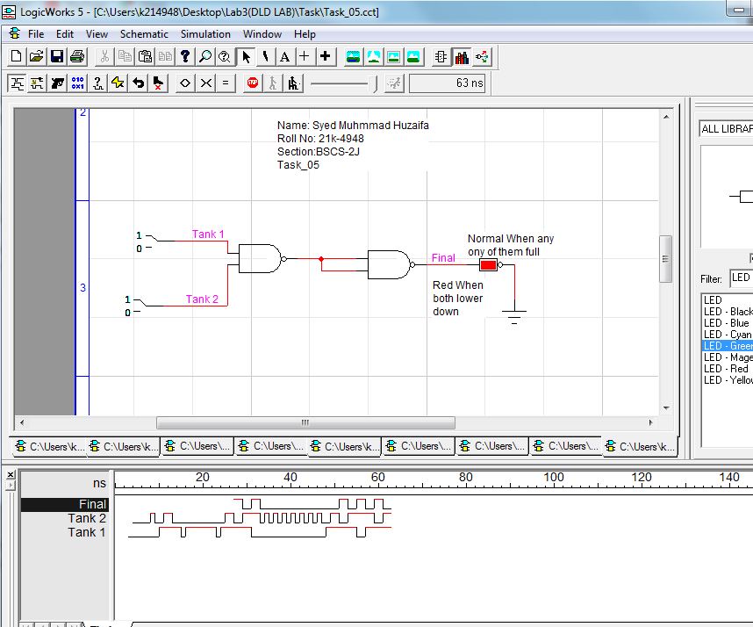

|  |  |  |
| --- | --- | --- |
| Tank 1 | Tank 2 | OUTPUT |
| 0 | 0 | 0 |
| 0 | 1 | 0 |
| 1 | 0 | 0 |
| 1 | 1 | 1 |

Exercise 6:

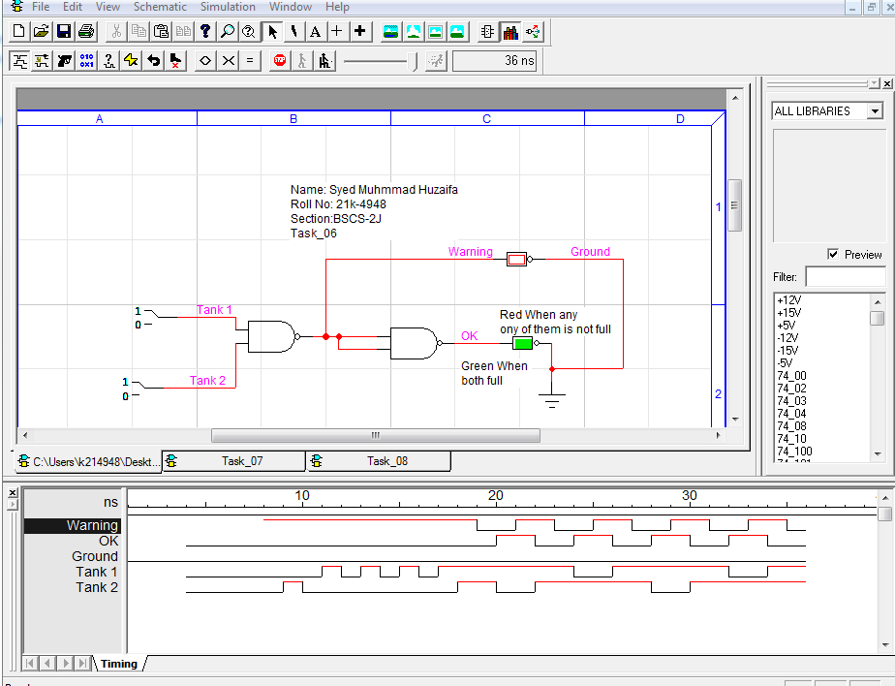

|  |  |  |  |
| --- | --- | --- | --- |
| Tank 1 | Tank 2 | X | Y |
| 0 | 0 | 1 | 0 |
| 0 | 1 | 1 | 0 |
| 1 | 0 | 1 | 0 |
| 1 | 1 | 0 | 1 |

Exercise 7:

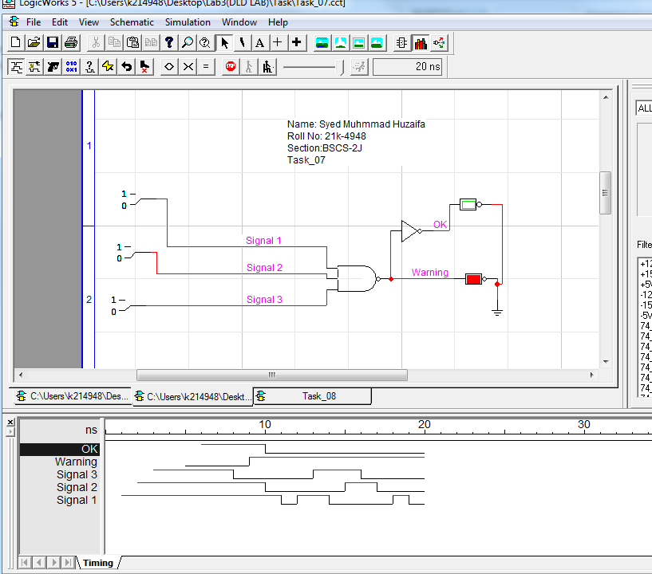

|  |  |  |  |  |
| --- | --- | --- | --- | --- |
| GEAR 1 | GEAR 2 | GEAR 3 | X | Y |
| 0 | 0 | 0 | 1 | 0 |
| 0 | 1 | 0 | 0 | 1 |
| 1 | 0 | 1 | 0 | 1 |
| 1 | 1 | 0 | 0 | 1 |

Exercise 8:

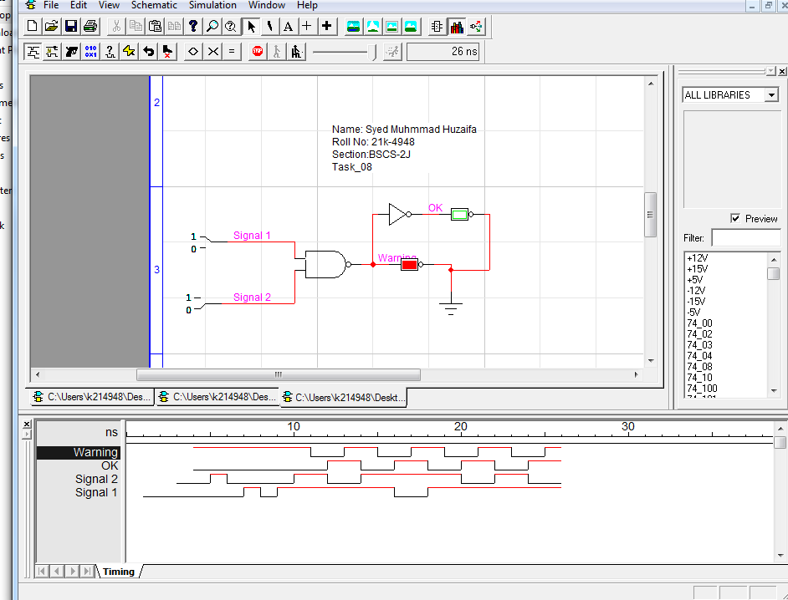

|  |  |  |
| --- | --- | --- |
| A | B | X |
| 0 | 0 | 1 |
| 0 | 1 | 1 |
| 1 | 0 | 1 |
| 1 | 1 | 0 |

**TRUE/FALSE**

1. An inverter performs a NOT operation. (True)
2. A NOT gate cannot have more than one input. (True)
3. If any input to an OR gate is zero, the output is zero. (False)
4. If all inputs to an AND gate are 1, the output is 0. (False)
5. A NAND gate can be considered as an AND gate followed by a NOT gate. (True)
6. A NOR gate can be considered as an OR gate followed by an inverter. (True)
7. The output of an exclusive-OR is 0 if the inputs are opposite. (True)